CHAPTER 1
ABSTRACT
  - The company
Digi Toad Technologies is a core Embedded Systems Solutions company founded in 2018 and located at AB square #617, 5th main OMBR layout, Bangalore, with its focus on supporting the engineering education in India, we are trusted by Educators, Researchers and Students for high quality products, training services and technology learning solutions specific to:
- Embedded Artificial Intelligence
- Industry 4.0
- Sensing & Data Acquisition
- Power Labs Ecosystem
They have collaborated with leaders from the industry such as STMicroelectronics,
Industrial Shields and Bitlismen to enhance engineering education experience among the learners, researchers and developers.
o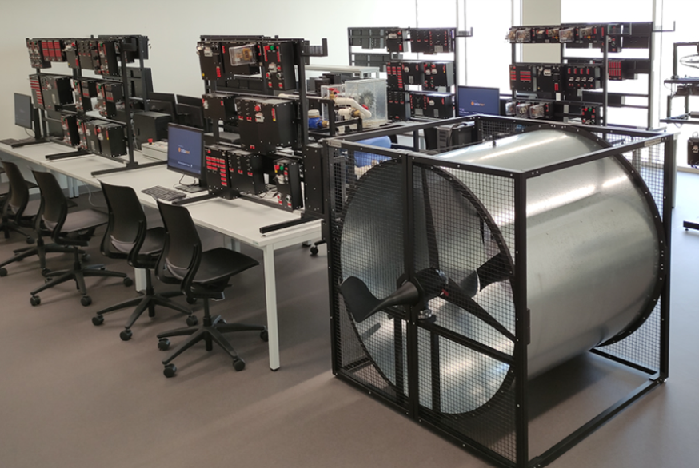 Digi toad electronics, Bengaluru, Karnataka.

  - The problem or opportunity or Area of Internship work
The internship is based on STM32 Microcontroller Nucleo-F104RE.
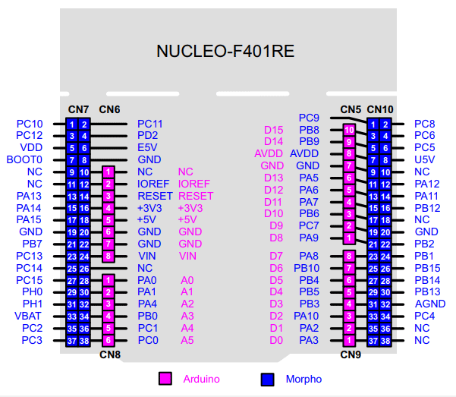
Pin diagram of Nucleo-64 F401RE
The STM32 Nucleo-64 board provides an affordable and flexible way for users to try out new concepts and build prototypes by choosing from the various combinations of performance and power consumption features, provided by the STM32 microcontroller. For the compatible boards, the external SMPS significantly reduces power consumption in Run mode.
The problem with the internship is that the tool used in the designing is licensed and the components used in the interfacing are not affordable if they are damaged. The installation takes more time in case of Nano Edge AI Studio. Detecting the samples maybe be difficult if there is external noise.
  - Methodology
For execution of the project, they introduced a software called Nano Edge AI Studio. Arduino IDE is used for execution of the code. The installation process starts with the installation of Nano Edge AI and Arduino IDE software’s.
ARDUINO:
While using Arduino we have to set the required board (nucleo-64), board part number and port. The board part number is different for different STM32 microcontroller. In Arduino preferences the STM32 Arduino GitHub get started code should be added in additional code preferences in order to get access of different libraries. Different libraries should be included in the Arduino using zip files or extracted files.

Installation of MPU 6050 library of upgraded version is needed for the execution.
Arduino 1.8.19→sketch→include libraries→manage libraries→search Adafruit_MPU6050→select version→install library.
Nano edge AI studio needs license. The codes required for the hardware interfaces are taken from different URL’s mentioned by the instructor like:
shorturl.at/fmvJO- where codes for LED interfacing are available.
Different libraries are also included in the Arduino which are required for the interfacing and hardware purposes.
NANOEDGE AI STUDIO:
For converting an analog signal to digital signal or for any audio signal transmissions the following steps has to be done: N-class classification
- Project settings
- Signals
- Benchmark
- Emulator
- Validation
- Deployment
Later the file from deployment is downloaded and extracted for the samples taken and the files in deployment are used to replace some libraries in Arduino like nano edge AI, knowledge.h, libneai.h…etc. The samples collected are replaced in the code of Arduino.

Benefits to the company/institution through your report.
The benefits to the company is that it helps to know the manufacturing and industrial settings, pairing embedded AI and the Internet of Things which result in predictive maintenance for equipment, increased operational efficiency, improved products and services, and enhanced risk management.

The institution can have an idea about the company and the internship which is provided by them and to what extent it is useful for gaining industrial experience.

CHAPTER 2
INTRODUCTION
2.1 History
An aircraft in flight is free to rotate in three dimensions: yaw, nose left or right about an axis running up and down; pitch, nose up or down about an axis running from wing to wing; and roll, rotation about an axis running from nose to tail. The axes are alternatively designated as vertical, lateral, and longitudinal respectively.
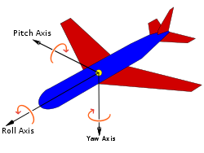
The position of all three axes, with the right-hand rule for describing the angle of its rotations
The motion sensor MPU6050 is connected to the Nucleo F105RE for capturing the different motions like motion in pitch axis, roll axis, yaw axis and the rest motion.

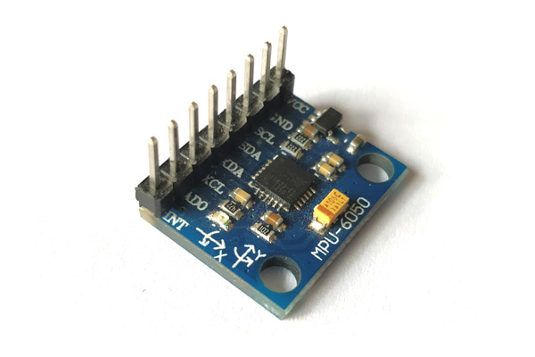
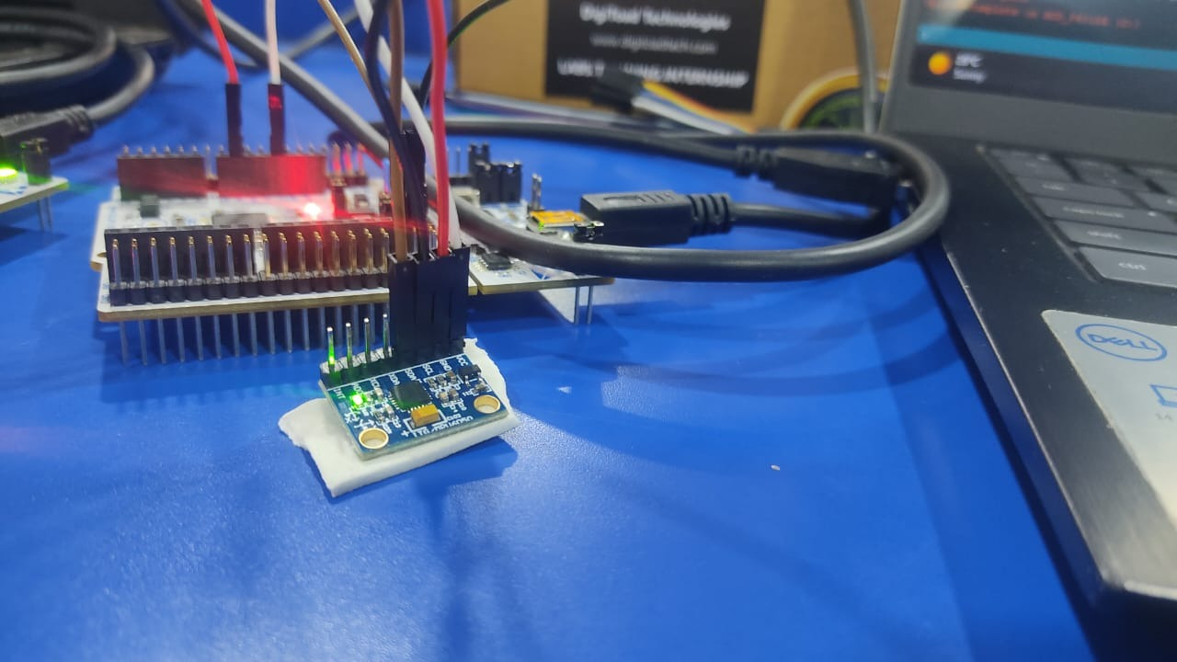

2.2 Definitions
The MPU6050 is a Micro-Electro-Mechanical Systems (MEMS) that consists of a 3-axis Accelerometer and 3-axis Gyroscope inside it. This helps us to measure acceleration, velocity, orientation, displacement and many other motion-related parameters of a system or object.
The STM32 Nucleo-64 board provides an affordable and flexible way for users to try out new concepts and build prototypes by choosing from the various combinations of performance and power consumption features, provided by the STM32 microcontroller. For the compatible boards, the external SMPS significantly reduces power consumption in Run mode.
The pitch axis (also called transverse or lateral axis) has its origin at the center of gravity and is directed to the right, parallel to a line drawn from wingtip to wingtip. Motion about this axis is called pitch. A positive pitching motion raises the nose of the aircraft and lowers the tail.
Roll axis is the motion of the aircraft rocking back and forth. Again, think three-dimensionally; in roll, the airplane's wings are tilting up and down. When the left wing is tilted up, the right is necessarily pointed down, and vice versa. Roll is controlled with the airplane's aileron.
Normal axis, or yaw axis — an axis drawn from top to bottom, and perpendicular to the other two axes, parallel to the fuselage station.

2.3 Architecture/Block Diagrams

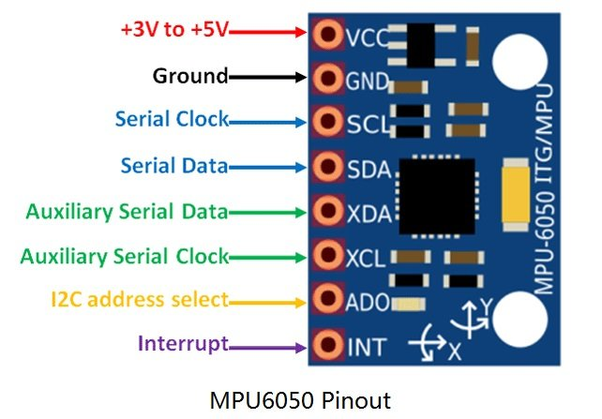

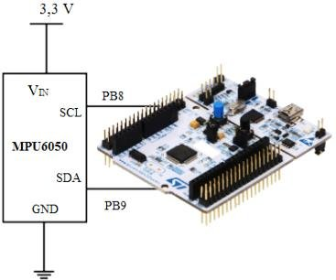

2.4 Configuring/Installing Peripherals
Installation of the Arduino and the required libraries are needed.
Installation of Nano edge AI studio is also needed. To start with Embedded AI design, installation of Embedded AI development tool chain is mandatory. In this the main tool for designing is Nano Edge AI Studio and the programming part requires Arduino 1.8.19. The codes required for the hardware interfaces are taken from different URL’s mentioned by the instructor like:
shorturl.at/fmvJO- where codes for LED interfacing are available.
Different libraries are also included in the Arduino which are required for the interfacing and hardware purposes.

2.5 Applications
1) This helps to recognize the movement of the plane. The MPU6050 sensor is used to understand the motion of plane.
2) Different vibrations and motions can be detected according to the requirements.
3) Designing PCB with micro-controllers, wireless interfaces, energy harvesting and sensors and test on the field.
4) Firmware implementation for low power and application.

2.6 Advantages & Disadvantages

Advantages:
- They are very compact in size, with high speed.
- Embedded Systems are very reliable.
- They consume less power and electricity, and they also perform task and operations assigned to them with great accuracy.
- They are built to perform special task and operations given to them.
- They can be customized for producing more enhanced results.

Disadvantages:
- The Embedded Systems are very tedious and difficult to upgrade and update.
- Requires lot of time and energy to maintain these systems.
- They are not associated microprocessor or microcontroller for processing.
- If system get damage or corrupt, they are completely changed and removed.

CHAPTER 3
INTERNSHIP DISCUSSION
3.1 How the objectives achieved?

- Installation of Embedded AI development tool chain
- Hands on Labs using STM32 GPIO- on board LED and Button.
- Introduction to Sensor Technology.
- Detection and identification of different audio signals.
- Detection and identification of different vibrations and motions using sensors.

3.2 What skills (scientific and professional) were learned during the internship?

- Installation of the tools required for the Embedded AI Design like Nano Edge AI Studio and Arduino.
- Working with Arduino for hardware implementation like blinking and button of LED and serial communication.
- Interfacing hardware using Nano Edge AI Studio.
- Different audio signals can be detected and identified using the tool.
- Analog signals are transmitted using the software and samples are generated.
Different vibrations and motions signals can be detected using sensors.

3.3 Results/observations/work experiences get in the internship
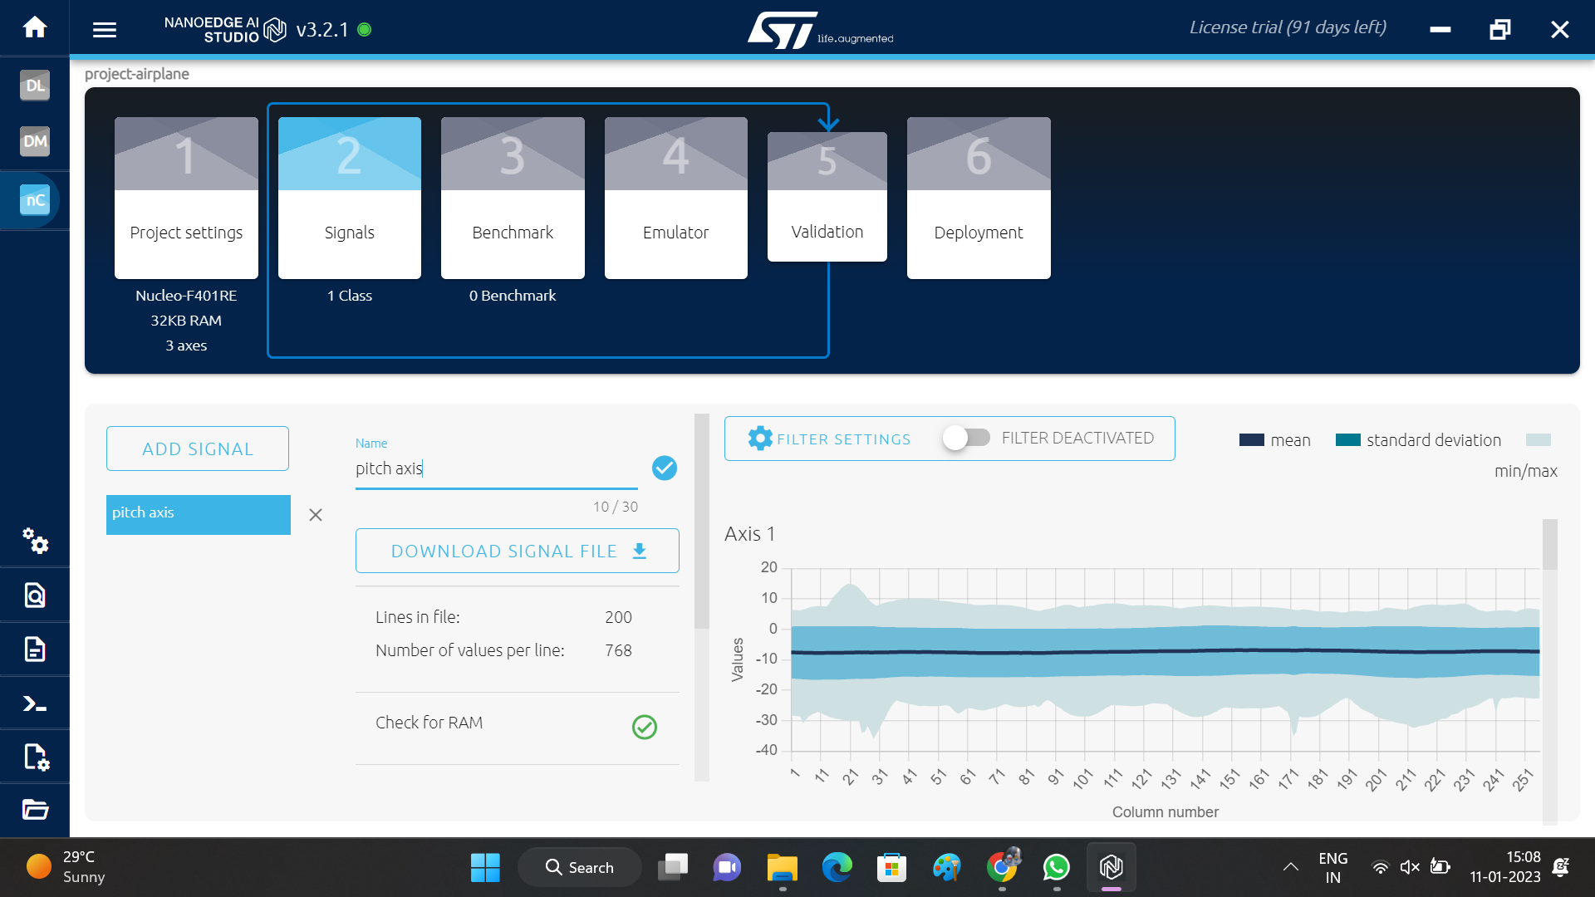 pitch axis

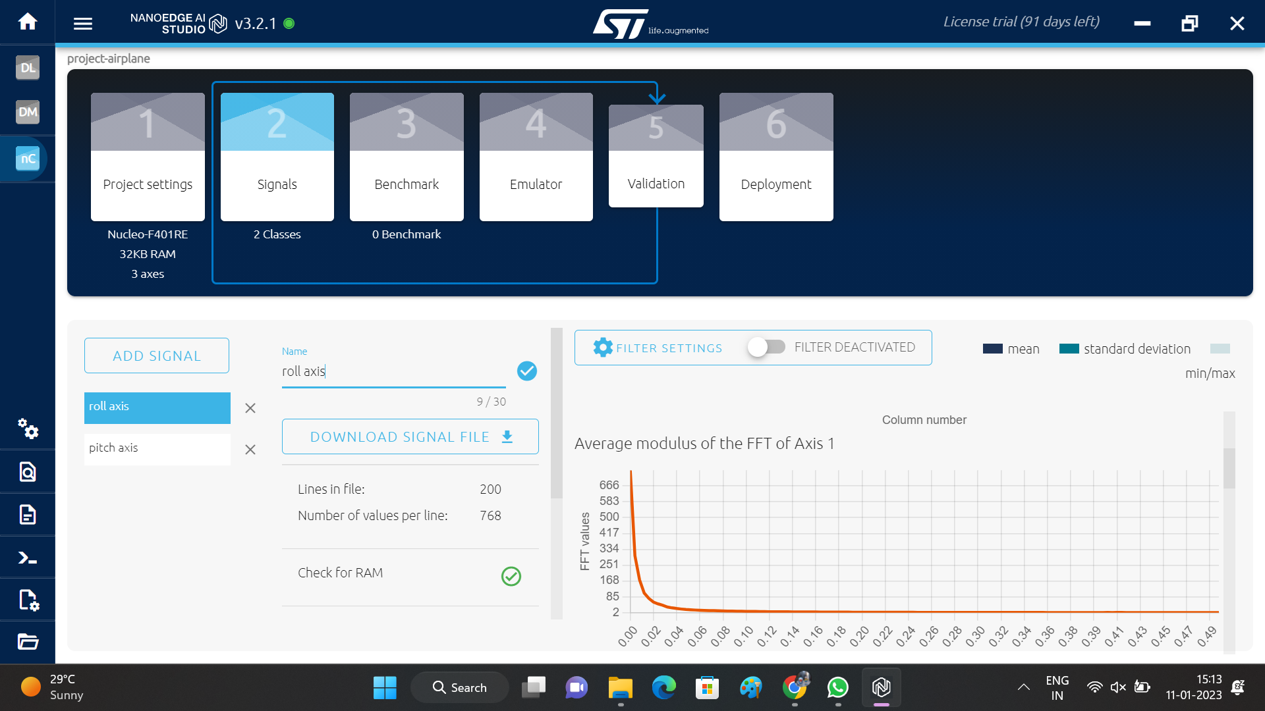 rollaxis

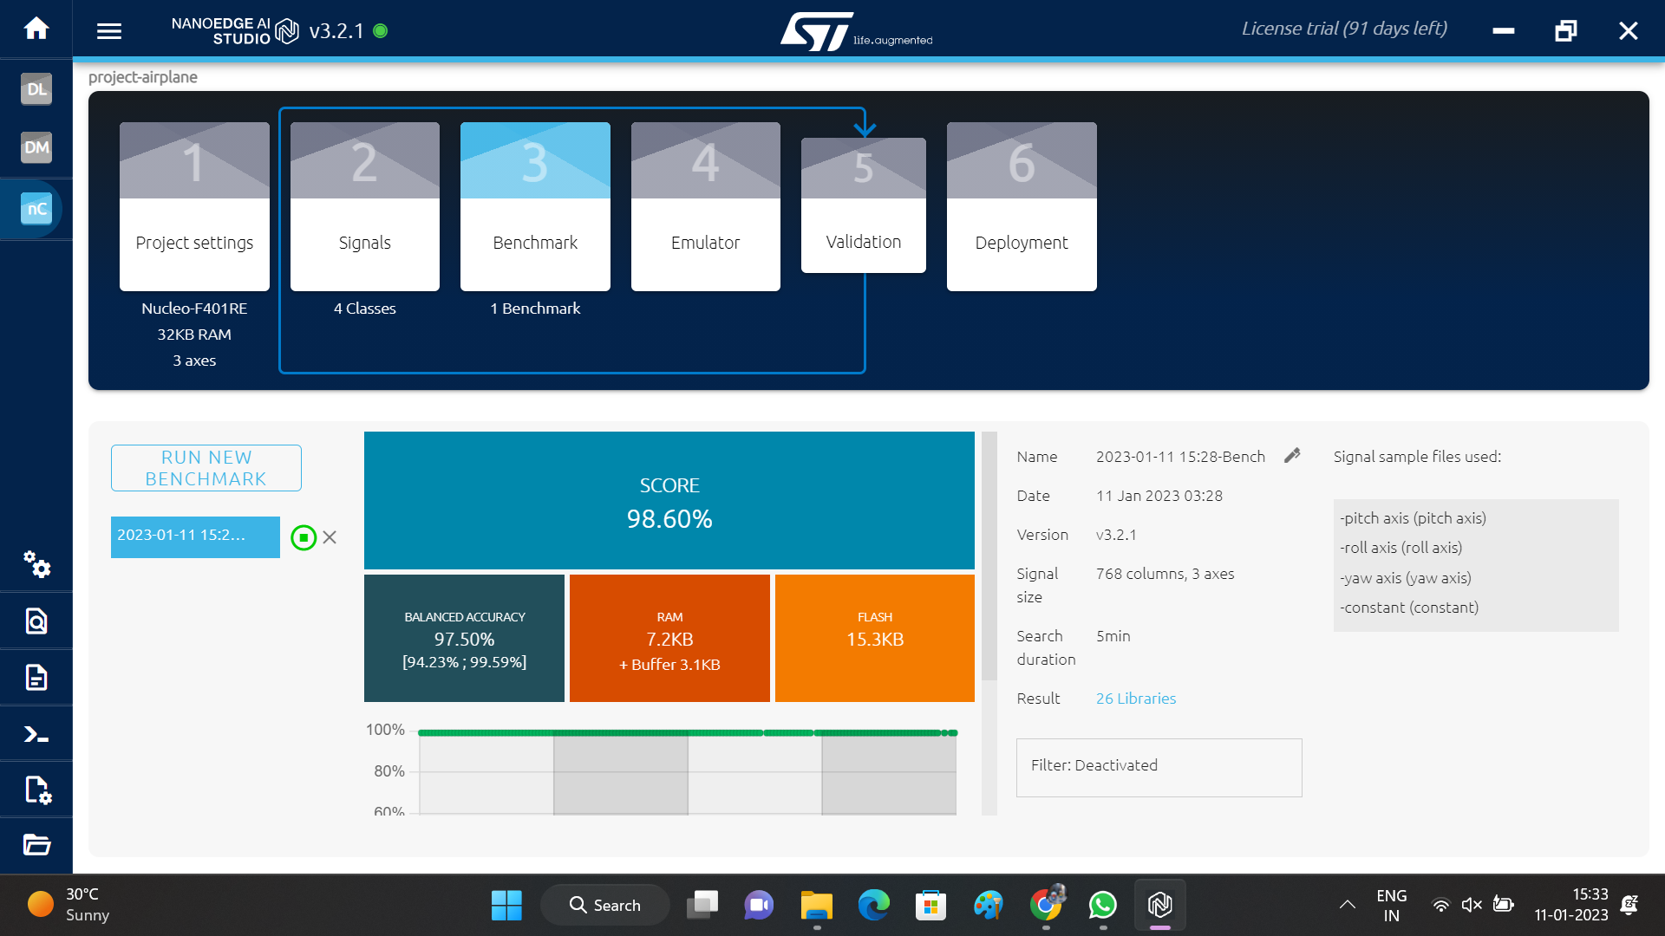 bench mark

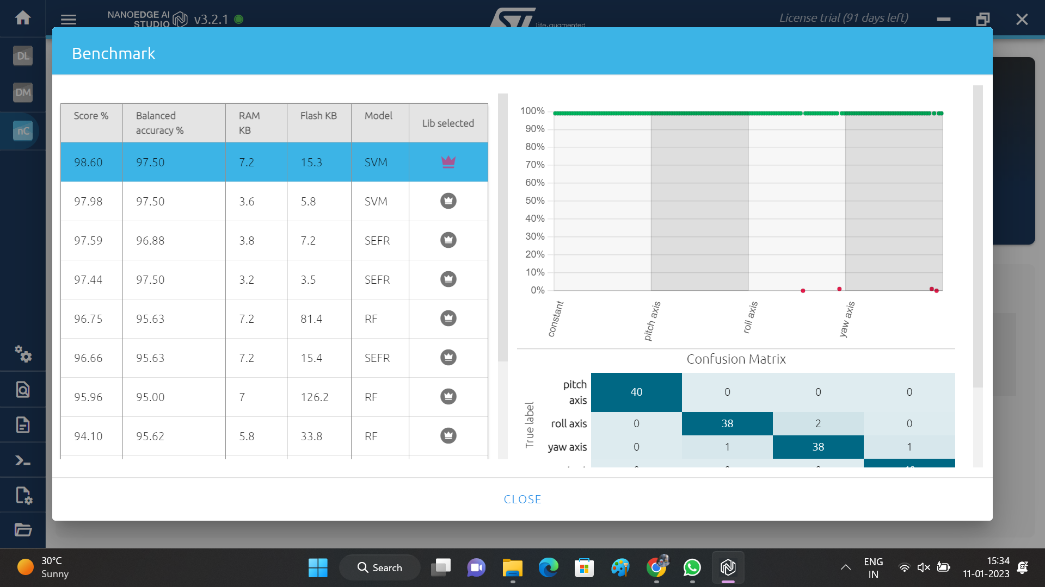 bench mark 1

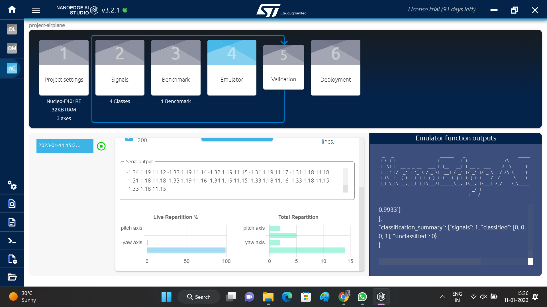 Emulator

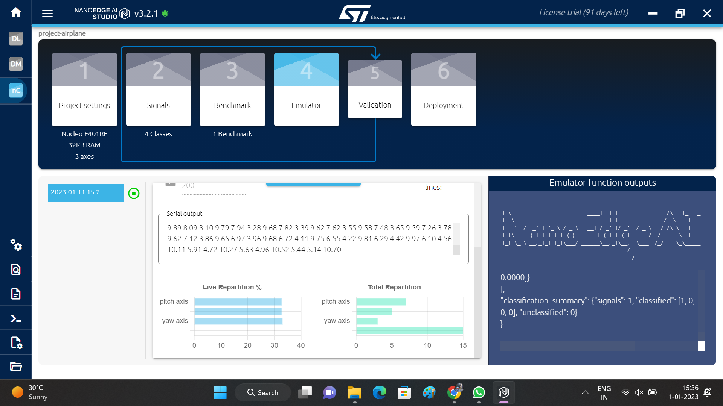 Emulator 2

3.4 What challenges did you experience during the internship?
- The problem with the internship is that the tool used in the designing is licensed and the components used in the interfacing are not affordable if they are damaged.
- The installation takes more time in case of Nano Edge AI Studio.
- Detecting the samples maybe be difficult if there is external noise.
- There may be problems in the cables for connections may become loose in the process of detection of signals.

CHAPTER 4
CONCLUSIONS
Embedded AI Design is performed using tools like Nano Edge AI Studio and Arduino.
- Interfacing using Arduino, STM32 and Nano Edge AI Studio is achieved.
- Different audio signals are detected and identified using the tool.
- Different vibrations and motion signals can be identified and detected using sensors.

REFERENCES
[1]. Andrew N. Sloss, Dominic Symes and Chris Wright (2008), ARM Systems Developer’s Guides - Designing & Optimizing System software, Elsevier, New Delhi, India.
[2]. Mohamad Hazwan Mohd Ghazali and Wan Rahiman, Vibration Analysis for Machine Monitoring.
[3]. Sara Anastasia , Marianna Madonnab , Luigi Monicaa, Implications of Embedded Artifical Intelligence.

